Plot Overview of the Aeneid
The Aeneid stars the Trojan warrior Aeneas, the son of Venus (the Roman equivalent of Aphrodite). You may remember him from the Iliad – he had to be rescued twice by the gods during battles. The driving force of this tale is the journey of Aeneas from Troy which will end in the establishment of Rome.
The Aeneid starts several months after Troy has fallen. The surviving Trojan fleet is sailing towards Italy. As they approach, the still-hostile Juno (the Roman equivalent of Hera) orders the god of the winds, Aeolus, to concoct a storm which will throw them off-course. They get blown all the way to Carthage in Libya. Carthage is ruled by Queen Dido. She gives the troops hospitality and even holds a feast for them. At this dinner, she asks Aeneas to relate what he and the Trojans have experienced.
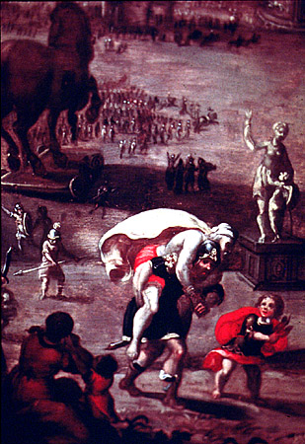
Aeneas tells the sad tale of the end of the Trojan war via the famous “Trojan Horse.” He relates many of the events of that night – Pyrrhus’ killing of King Priam, the death of Aeneas’ wife Creusa – but the most famous part of his tale is his own escape from the burning city. Carrying his aged father Anchises on his shoulders and leading his young son Ascanius by the hand, he and some other warriors are able to flee with their lives.
Aeneas relates that after the Greeks had left in triumph, what remained of the Trojan fleet sought to relocate the city in a new place. They intially chose Thrace and started building there, but they were warned by the ghost of Polydorus, a son of Priam, that they must go. (Polydorus had been killed by the king of Thrace).
Next, the Trojans landed on the island of Delos where the oracle of Apollo resided. When Aeneas visited the oracle, he was told he needed to find his “ancient homeland.” At first, they believed that homeland to be Crete. However, when they arrived, they discovered that their true homeland was Italy. On the way, they stopped at the island of Strophadës where they encountered the Harpies (half-bird, half-woman, the Harpies are cruel torturers). They were able to escape from that island, though, and head to Buthrotum.
Buthrotum is the new home of Helenus, Priam’s son, and his wife, Andromache, the woman once married to Hector. After consulting Helenus on then best way to reach Italy, the fleet sailed on. During a brief stop at Sicily, Aeneas’ father Anchises died. When they left Sicily, they encounted Juno’s storm and were swept to Carthage.

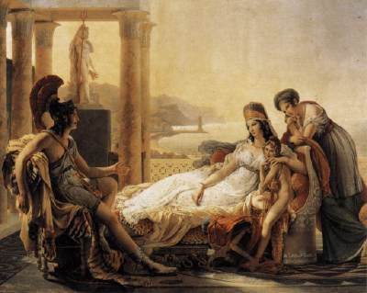
Now the story is back to where it began. As Dido listens to Aeneas, she falls in love with him. Her sister Anna advises her to act on her desire and seduce Aeneas. With the help of Juno (who wants to stall Aeneas) and Venus (who wants to make her son happy), Dido entices Aeneas to bed. After they become intimate, Dido considers them as good as married and believes he will stay with her forever. Aeneas loves her and would like to do so, but after one year he is commanded by Jove (the Roman equivalent of Zeus) to leave and go to Italy. Feeling he has no choice, Aeneas sadly obeys. Unable to deal with losing him, Dido first curses the Trojans (a curse which will come to fruition through the Punic Wars), then kills herself.
The Trojans once again head to Italy, but get blown back to Sicily by another storm. Aeneas discovers that his father’s death on that island has not been forgotten; funeral games and sacrifices are made in his honor. After a bit, the men are prepared to sail on, but troublemaker Juno once again interferes and inspires the Trojan women to set fire to the ships. (The Trojans had been sailing around looking for a home for seven years at this point.) Working against her, Jupiter sends rain to put out the fire. Only four ships are lost. However, the incident does lead to Aeneas giving the option to the Trojans to stay in Sicily if they like. The rest will go with him to Italy. As they are about to set sail, Venus asks Neptune to ensure her son will have a safe trip on the sea. Neptune agrees, but only if one human is sacrified to him. The sacrifice is Palinurus, the ship’s pilot. He falls overboard but is able to struggle back to shore; however, the moment he pulls himself out of the water onto the cliffs, he is killed by savages.
With Neptune watching over the fleet, they are able to safely reach Italy (aka Latium). Once there, Aeneas goes to a sibyl (a priestess of Apollo and Diana). She takes him to the underworld where he sees many horrors, but also gets a vision of Rome’s future courtesy of his father’s ghost. Encouraged by his vision, Aeneas starts to set up shop in Latium. The king of the region, Latinus, cooperates, but his subjects are not so quick to help. Under the leadership of Rutlian Prince Turnus, they attempt to drive the Trojans away. Even Latinus’ wife Amata gives him no peace. She has her eye on Turnus as the future husband of their daughter Lavinia.
Sure enough, the two sides come to war. Aeneas allies himself with Evander, the king of Pallanteum (the future site of Rome). He also gets the help of the Etruscans. Before Aeneas can return from his mission to enlist help, the war breaks out between the Trojans and the Latins. Aeneas returns with reinforcements from Pallanteum and the battle rages. Pallas, the son of Pallanteum, is killed by Turnus, but Aeneas takes down both Mezentius and his son Lausus. The Trojans gain the advantage and attack the main citadel, Laurentum. King Latinus continues to plead for peace, but Turnus refuses. Instead, after the death of his warrior woman Camilla, he challenges Aeneas to one-on-one combat. The winner will determine the end result of the war, and get Lavinia as a wife to boot. Aeneas defeats Turnus and both the war and the epic come to a conclusion.

