Ludovico Ariosto and Orlando Furioso

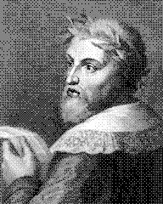
Background on Ariosto (1474-1533)
Born in Italy, Ariosto was a poet/author who, while having to endure many tiresome jobs to earn his way, still managed to produce one of the most famed works of the Italian Renaissance, Orlando Furioso (1532). He was the son of a count who initially studied law, but yearned to concentrate on his true love, poetry. After his father’s death, he supported the family due to the fact he was the eldest of 10 brothers and sisters. He at various times commanded a fort, worked as a type of manservant to a Cardinal called a familiare, and governed the Garfagnana region in the Apuan Alps (a high-crime area where he was miserable). After three years, he returned to marry his true love, the widow Alessandra Benucci, and dedicated the rest of his life to perfecting Orlando Furioso.

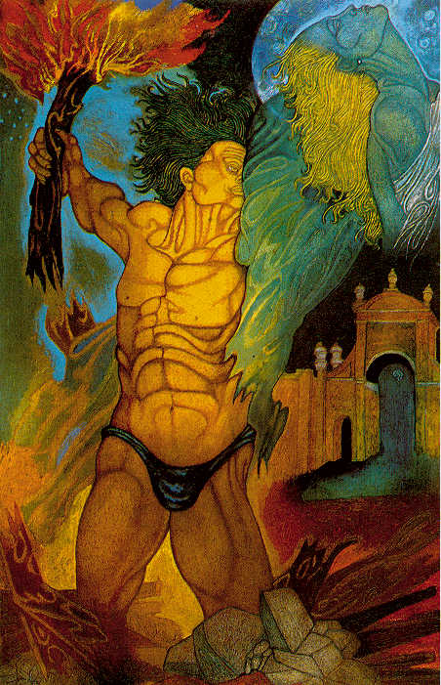
Orlando Furioso
Orlando Furioso is a quasi-continuation of Boiardo’s Orlando Innamorato from 1494. In that work, the famous knight Orlando falls hopelessly in love with Angelica, who spurns him. Also interwoven with that plot are many various subplots, a tradition Ariosto maintains even as he in many ways parodies Innamorato. Some plot factors that remain constant besides Orlando’s obsession with Angelica are his position as a Christian knight under Charlemagne venturing into the land of the Moors, North Africa, and other regions in his adventures.

Ariosto details Orlando’s madness in a way that incorporates characteristics of epic, romance, pastoral, tragedy, comedy, praise poem, and satire. He deals with themes of war, love, chivalry, the roles of men and women, passion versus reason, nature versus nurture, and the contradictions of his world. In the end, Orlando recovers himself. However, his story, along with the tales of many of his fellow knights adventuring in the same parts of the world, make up one of the most fascinating works of the time.

