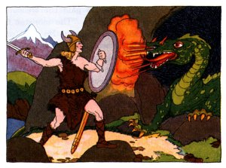
Characters in Beowulf

Beowulf – hero of the story; a Geat warrior who is able to defeat three different monsters and rule the Geats

Danes

Aeschere – advisor of Hrothgar

Hrethric – older son of Hrothgar and heir to the throne, but thwarted by his cousin Hrothulf

Hrothgar – King of the Danes; the one who is harassed by Grendel until Beowulf comes along

Hrothmund – younger son of Hrothgar

Hrothulf – cousin of Hrethric and Hrothmund; nephew of Hrothgar. He steals the throne from its rightful king, Hrethric

Unferth – Danish warrior who insults Beowulf

Wealhtheow – Queen of the Danes; Hrothgar’s wife

Geats

Breca – Childhood friend of Beowulf; lost swimming match between the two

Ecgtheow - Father of Beowulf’s father; sought sanctuary with Hrothgar in the past

Hrethel – Geatish king; took care of Beowulf after the death of his father Ecgtheow

Hygd - Queen of the Geats; wife of Hygelac

Hygelac – King of the Geats; uncle of Beowulf

Wiglaf – A follower of Beowulf, he is the only warrior to remain with Beowulf when he fights the dragon.

Monsters
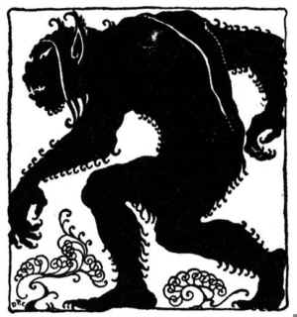
Grendel – outcast monster who harasses Hrothgar and his people

Grendel’s mother – also an outcast monster of the swamp who attempts to gain vengeance for her son’s death

Dragon – the third and final monster Beowulf fights

