Pilgrims of Chaucer’s Canterbury Tales

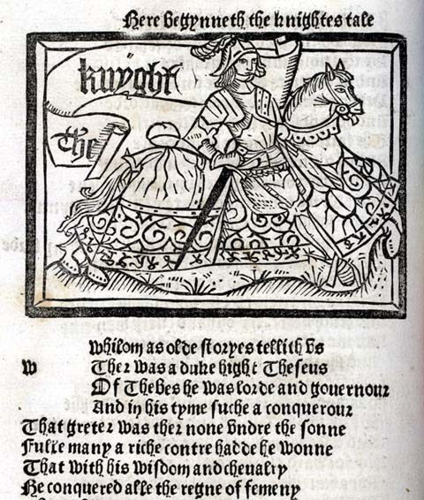
The Knight
Presented as the ideal “Christian knight” and medieval soldier who has fought in many fourteenth-century wars against pagans in Eastern Europe and the Middle East. His appearance is described in terms of the fact that his clothing still bears the marks of battle – he was so eager to begin his pilgrimage that he did not even change clothes.

The Squire
The son of the knight, he is in training to become a knight himself. He, too, has seen some battles and is a dutiful assistant to his father. He attempts to prove himself to ladies by his deeds like a good courtly lover, but is driven by passion and kept up at nights fantasizing about women. He is likely to please them, though, because he can sing, dance, and write poetry. It doesn’t hurt that he is handsome and fashionable in attire.

The Yeoman
A yeoman is a countryman who is an independent commoner and owns his own land. This yeoman acts as the knight’s military servant. He is defined as one who is familiar with the forest and woodcraft. As such, he wears green and carries a bow and arrows along with his sword, shield, and dagger. He wears the badge of St. Christopher who is the patron saint of travelers and foresters.

The Prioress
A prioress is the head of a convent. She is described as simple, coy, educated, but not well-traveled. She practices perfect social graces and manners, and is highly sensitive, especially to the plights of animals. Her vanity regarding her appearance belies her air of the proper nun, however. She also has an interesting inscription on her brooch: Amor vincit omnia (“love conquers all”).

The Monk
Despite the fact that he is a monk, religion is not central to his life. He is a “roving overseer” for the monastery. Other than that, he spends a lot of time concerned with horses and does not adhere strictly to teachings. He does not study or do hard labor as suggested by Augustine for monks. He instead enjoys hunting, spending a great deal of money on his hobby. He is bald, portly, and sweats a lot, but is dressed well.

The Friar
Hubert the Friar is described as “wanton” and “merry” and one who has wooed many women, causing them to marry others. (This is a bit ambiguous – did he perform the ceremonies or make them need to seek husbands because of his own relations with them?) He certainly is not an ideal friar. He sells absolutions and frequents taverns. Additionally, though he is a peddler on the side, he takes from those who have nothing. He is heavy-set and bright-eyed.

The Merchant
Like most stereotypical merchants, he is most concerned with making money. His earnings come from exchanging currency, but despite all his efforts and stylish appearance, he is in debt.
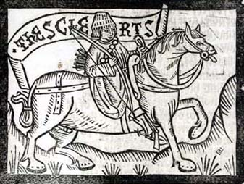
The Oxford Student (aka the Clerk)
He is an intent scholar who never has any money, but what little he gets from borrowing, he spends on books. He has dedicated his life to the pursuit of knowledge and is happy to teach as well as learn. Because all his money goes to books, he is thin and wears threadbare clothing.

The Lawyer
He seems very wise and is shrewd in the practices and precedents of the law, but he is not as successful as he would have everyone believe. He also uses his position to speculate land and purchase it at a low price.

The Franklin
A franklin is a landowner who is free but not of noble birth. This franklin is wealthy and has a great appetite for food. Also, he is always looking to have a good time.

The Five Guildsmen (Weaver, Dyer, Carpenter, Tapestry-maker, and Haberdasher)
The guildsmen are all members of a fraternity with both social and religious functions. They earn comfortable livings and have well-respected wives. They look neat and clean; each wears the garments of their guild. (Note: a haberdasher is a merchant who deals in clothing).

The Cook
He travels with the guildsmen and cooks well, especially thick rice pudding. He also has a sore oozing puss on his shin.

The Skipper
While he is described as a good fellow, he is also dishonest, stealing wine. Even worse, he is not honorable and drowns prisoners of war. Regarding sailing, though, he knows his stuff. He is tanned and wears a dagger.

The Physician
He uses astronomy as the basis for his medicine and keeps to the medieval belief of the balance of “humors” controlling one’s health. Much sickness was believed to be caused by an overabundance of the hot, cold, moist or dry humors. He sends his clients to druggists to buy medicine in a lucrative mutually beneficial partnership. He is not a bad doctor, though; he utilizes the learning of ancient and current physicians to help his patients. He is moderate in all things but is overly dedicated to acquiring gold. He has been somewhat successful, judging from his fashionable dress.
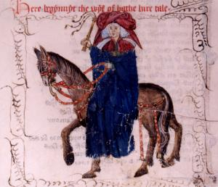
The Wife of Bath
Her most notable traits are her insatiable sexual appetite, her need for dominance, and the fact that she has had five husbands. She knows all about love as a result. She is described as a talented weaver, although somewhat deaf. She displays pride in her insistence to be the first to make an offering in church. Well-traveled and well-attired, she is “gat-toothed” and florid (both signs of passion).

The Parson
Finally, a good man of religion. He is poor but upright in thought and deed. Learned as well as holy, he practices what he preaches and sets an example for his parishioners. He visits his parishioners in need no matter how far away they may be; he is described as “benign, diligent, patient.” He does not harass people for tithes and does not care about wealth or self-advancement. In short, he is an ideal parson.

The Plowman
The brother of the Parson, he too loves God and strives to do right. He gives to the poor, pays his tithes, and loves his neighbor as himself.

The Miller
He is described as big and strong, able to break any door by running at it with his head. Along with his red hair and beard, he has a wart to the right of his wide nose and above his large mouth. He sings ballads, tells bawdy jokes, and plays bagpipes, but all is not fun and games. He is also dishonest and tips the scales to his own benefit when weighing out grain for his customers.

The Manciple
The manciple is the purchasing agent for a law court and a business agent of the lawyers. He is shrewd, although not as well-educated as the lawyers.

The Reeve
A reeve is the steward of a manor. This reeve used to be a carpenter and currently has his own farm, but he is a shady character. He knows all about cheating and allows no one to get the best of him, his lack of trust demonstrated by the fact that he rides in the back of the party. All the men who worked for him are deathly afraid of him for he is ruthless in his dealings. Thanks to his shady practices, he has money that he keeps in his house.

The Summoner
This man serves summons for the ecclesiastical courts, which regulated morals and domestic life. He is a lecherous, overly sexual type who has far too much influence over the young girls of the diocese. He has a skin disease that makes his face appear to have a rash and scare little children. (His love of garlic, onions, and leeks were supposed to cause increased sexual appetite and skin problems). Another appetite he over-indulges is his thirst for alcohol; when drunk, he yells in Latin. He is not well-educated. When he wants to sound intelligent, he simply repeats what he has heard others say.

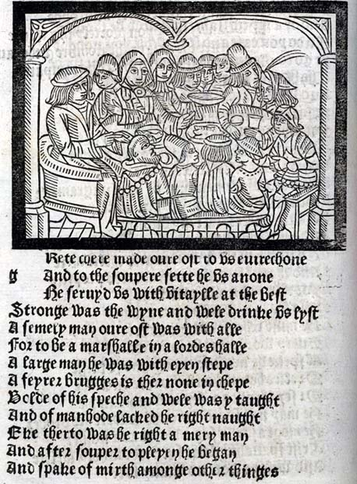
The Pardoner
Traveling with the Summoner, the pardoner is another hypocritical religious figure who dishonestly sells pardons to sinners under false pretenses. He sells fake holy relics to the poor. Sadly, his scamming has made him wealthy.

The Host
A large man, he is a good host, welcoming and accommodating to his guests. He does demand attention and respect in return, but he is described as well-spoken, wise, well-taught, and well-rounded as a man.

