Classic of Poetry (Shi Jing)

Also called the Book of Songs, the Classic of Poetry is the first major collection of Chinese poems. It combines both odes of the aristocrats and folk songs of the common people. Its poems date from 1000-600 BC.

Cultural Import
The impact of the Classic of Poetry on ancient Chinese culture is tremendous. It promoted the idea that one should speak from the heart. Like Homer’s epics, the Classic of Poetry gave Chinese people a common text through which they could understand moral lessons and cultivate cultural unity in a variety of peoples.

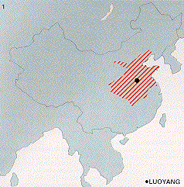
Dynastic Context
The poetry was written and collected during the Chou (Zho) Dynasty which lasted from 1020 - 221 BC (location pictured at left). While imperialistic, it was much less despotic than the Shang period which preceded it, and had agrarian roots. Philosophers of the time believed that the emperor ruled by divine right. Over the first 300 years (the “Western Zhou” Period), what began as a type of feudal unification of tribes turned into an alliance of city-states that made up a unified kingdom. The kingdom split, however, in 771 BC, and what is known as the “Eastern Zhou” Period began. It is divided into two sub-periods: the “Spring and Autumn Period” (770-476 BC) and “Warring States Period” (475-221 BC). In 221 BC, the kingdom was once again unified under one emperor, the brutal Ch’in Shih-huang. The Classic of Poetry was compiled in the Spring and Autumn period, before the deterioration into the violent Warring States Period.

Structure and Thematic Commonalities
1) Simple on the surface.
2) Usually dealt with agrarian imagery, dynastic issues, or courtship and marriage.
3) Usually composed of lines of four syllables, often with rhymed endings in the original Chinese. Many times, the four syllables are four pictograms when the poems are written with Chinese symbols.
4) Involves contrasts.
5) Aims to bring some kind of awareness to the reader.

