Sir Gawain and the Green Knight (c. 1380)

Background:
Sir Gawain is part of a single manuscript that also contains other three other poems: Pearl, Patience, and Cleanliness (or Purity). The author is anonymous. We do know the author lived in the late fourteenth century. It is speculated that he was from the West Midlands of England due to linguistic and scenic evidence.

The Medieval Romance Genre:
Sir Gawain has many conventions of the medieval romance genre. These include: 1) a celebration of a warrior society; 2) an emphasis on chivalry and courtly love; 3) a focus on nobility and the court; 4) an inclusion of pageantry and attention to detail in dress; 5) an opening that refers to a classical past; 6) descriptions of the central characters and kingdom as the all-time best/greatest/most beautiful, etc.

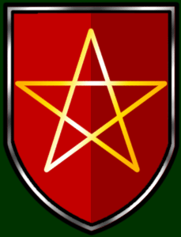
Chivalric code:
In medieval times, a system of values known as “chivalry” developed which dictated what the ideal attitude and behavior of a man should be, as represented through the knight. These values developed from various influences such as the Germanic tribe system and Christian values. The code stressed religious devotion, strength in arms, loyalty to one’s lord, generosity, faith, charity, humility, chastity, honesty, honor, courtesy, ritual, and etiquette. Also, a perfect knight should be well-versed in the arts, intelligent, eloquent, and able to excel in pastimes like jousting and hunting.

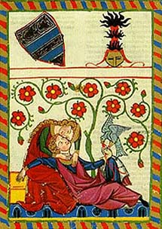
Another major component was the issue of the treatment of ladies and “courtly love.” A knight was to treat his beloved as he would a lord in the sense that he served her and did brave deeds to earn her approval. He did not expect consummation and indeed, often the woman was married to the knight’s lord or someone of a higher social status. Marriage was not the goal of courtly love; instead, courtly love served to inspire knights to greatness.

Poetic structure:
In its original Middle English, the poem follows the traditional form of Middle English poems that use alliteration in long lines. (Our text tries to keep as much poetic form as possible). Each line is divided into two half lines separated by a caesura (pause), and each half-line has two stressed syllables. The halves are joined through the use of alliteration.
Stanzas are 15-25 lines. Each stanza ends with a “bob and wheel.” A “bob and wheel” is constructed of five short lines which rhyme. Their poetic pattern is a-b-a-b-a. The initial short “a” line is the “bob” and the rest of the lines, “b-a-b-a,” make up the “wheel.” You will see these set apart in your text – the first example is on page 1993.

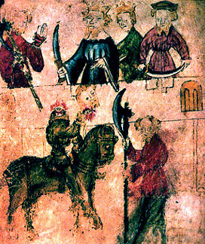
Food for Thought
- Do you think Gawain is a good knight, in the terms of his society of chivalric values? What does he think about himself? What do others think of him?
- How is Christianity, religion, and the supernatural brought in to the story? What about pagan elements?
- What are parallels between the hunts of Bercilak and Gawain’s dilemma back at the castle?
- Why is it so important for Gawain to resist the advances of Bercilak’s wife?
- Examine the debate between Gawain and Bercilak’s wife over how a good knight should act in terms of the chivalric code and the treatment of ladies.
- How does sex function in the text?
- In what way does Gawain not keep the chivalric code, eventually? What did he do wrong and why?
- How are women portrayed in the story?
- What is the importance of honor and justice in the story?
- How does nature and human nature play into the plot?
- Compare and contrast the Green Knight to Gawain. What might the Green Knight symbolize?
- What complicates this work in terms of the romance genre?

