Golden Age of Japanese Culture

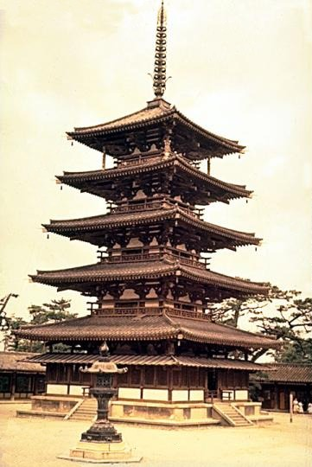
Development of Japanese Identity
- During the third century, rice cultivation acquired an important place in Japan, bringing a gradual end to the hunter-gatherer culture that had been in place.
- The importance of economy on the small island of Japan facilitated the belief that the needs of the many outweigh the needs of the individual.
- With the concurrent development of bronze and iron in the fourth century came the development of weapons and warfare, which eventually gave rise to the samurai culture so closely associated with Japan.
- Although early governors attempted to use Chinese models of administration in Japan, they were largely unsuccessful. Kinship structures that emphasized family and lineage were in opposition to the theoretically egalitarian bases of Chinese theories of meritocratic government.
- Japanese adoption of Chinese letters in the eighth century provided a basis for a national literacy.

Buddhism in Medieval Japan
- First introduced in Japan in 584; adopted by the emperor who believed that Buddha had healed him from a deadly illness.
- In the sixth and seventh centuries, centralizing religion helped strengthen centralized government.
- In 685, the emperor issued a mandate that every family have a Buddhist shrine in their home.
- At this time, Japanese Buddhism centered on form and ceremony.
- The transitory nature of Buddhism appealed to the Japanese culture of impermanence which emphasized the fact that the world was always changing.
- Reincarnation and the eventual escape of this world appealed to the same impulse in Japanese culture.

The Man’yoshu
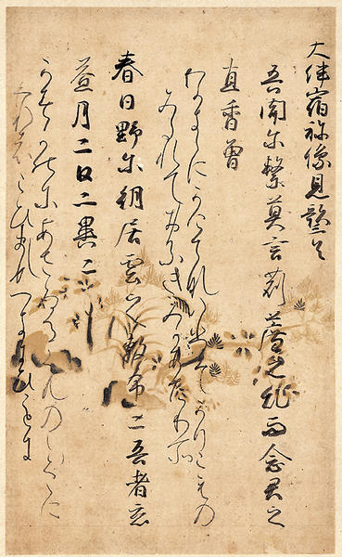
- The first great literature of Japan, it is a mammoth collection of poetry by various authors (many anonymous). Its title is translated “The Collection of Ten Thousand Leaves” and it was compiled in the eighth century (the last dated poem is 759).
- Most poems are in tanka form. Tanka poems are short – 31 syllables – with syllabic/line breakdown as follows: 5, 7, 5, 7, 7. They are like the last five lines of the choka, described below.
- There chokas are long poems. There is no set number of lines. The lines alternate between 5 and 7 syllables, but end in a couplet of 7 syllable lines.
- In The Man’yoshu, many chokas have introductory and following tankas called “envoys.”

