The Origins of Greek Mythology
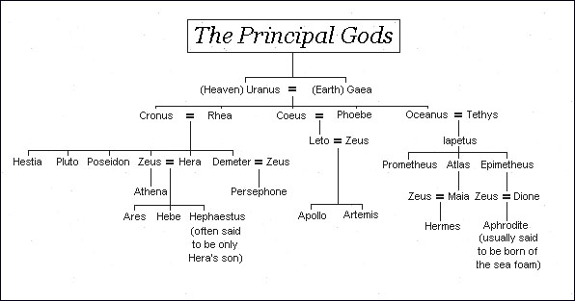
Greek gods, like the Sumerian gods, are not necessarily moral or just. They are simply immortal beings who do as they wish, and humans are left to supplicate, worship, flatter, appease, and hope that they don’t anger or annoy a god accidentally.

The Greeks believed that in the beginning, there was Chaos. From that was born Uranus and Gaea. They ruled the world as the primary gods, giving birth to creatures like the Titans and the Cyclopes. However, Uranus had a bad habit of throwing his children into the Underworld, so Gaea and her sons overthrew him.

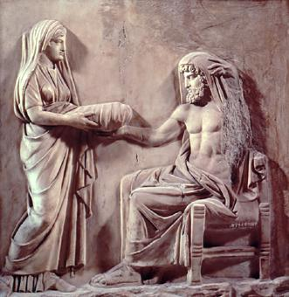
In his place ruled Cronos, the youngest Titan. He and his wife Rhea gave birth to all the major gods and goddesses we know as the Olympians, such as Zeus, Hera, Poseidon, and Demeter. However, Cronos, fearful of a prophecy that he would be defeated by his son, swallowed all of his children whole. Rhea was able to save Zeus by handing Cronos a stone to swallow instead of the baby. She then hid Zeus. After he grew up, he came back, defeated his father, and forced him to vomit up all of his brothers and sisters (still alive and well). From those major gods descended more gods such as Athena, Ares, Apollo, and Artemis, and the pantheon of Greek gods emerged.

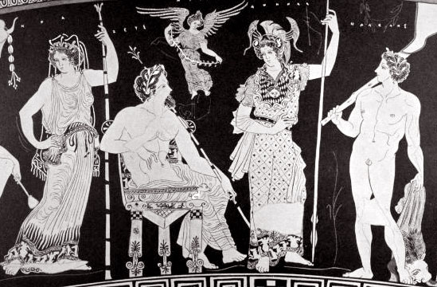
A quick run-down of the Pantheon

Olympians

Aphrodite – goddess of love
Apollo(n) – god of healing
Ares – god of war
Artemis – virgin goddess
Athena – goddess of wisdom
Circe – goddess of poisons and spells
Demeter – goddess of the harvest
Eos – goddess of the dawn
Eros – god of love
Hades (aka Pluto) – god of the underworld
Hebe – goddess of youth
Helios – god of the sun
Hephaestus – god of the smith
Hera – queen of the gods
Hermes – the messenger god
Hestia – goddess of the earth
Hypnos – god of sleep
Persephone – queen of the underworld
Poseidon – god of the sea
Thanatos – god of death
Zeus – king of the gods

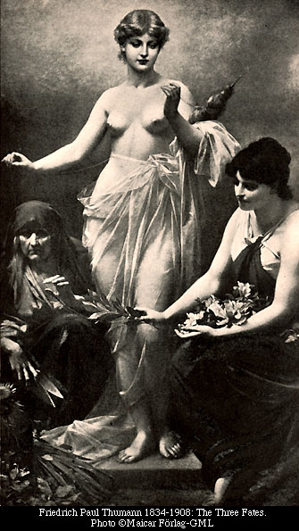
Other major supernatural beings
Fates – three sisters who spin, weave and cut the threads of life
Gorgons – three sisters so ugly they turned people who saw them into stone (for instance, Medusa)
Muses – nine sisters who inspire the arts
Sirens – half-birds, half-women, they lure men to their deaths with their irresistible song.

From the-pantheon.com

