Character List – The Iliad

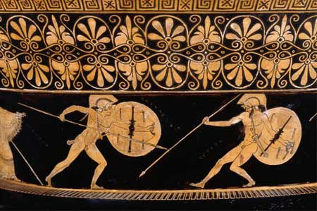
Achilles battles Hector

The Greeks (Achaeans, Argives, Danaans)

Achilles – Known as “the most violent man alive” and the best warrior in either army. His mother is the sea nymph Thetis and he is the commander of his own contingent of fighting men known as the Myrmidons.

Agamemnon (aka Atrides) – Commander of the Argives, king of Mycenae, and older brother to King Menelaus.

Ajax – The best warrior after Achilles. He is a huge guy.

Calchas – The most gifted soothsayer among the Greeks.

Diomedes (aka Tydides) – The youngest commander.

Idomeneus – King of Crete.

Menelaus – King of Sparta and Helen’s ex.

Nestor – King of Pylos and the oldest commander. He usually is the advisor due to his great wisdom, experience, and oral skills.

Odysseus – Ruler of Ithaca. Known for his brains, he is tactful and persuasive.

Patroclus – Best friend of Achilles.
The Trojans

Hector – Foremost soldier of Troy as well as its prince.

Priam – King of Troy.

Hecuba – Queen of Troy.

Paris (aka Alexander) - Prince of Troy who started it all by abducting Helen. Gorgeous but not a great warrior by any means.

Helen – Beautiful former queen of Sparta; abducted by Paris and now his wife.

Aeneas – Son of Aphrodite and important nobleman of Troy.

Andromache – Hector’s wife.

Astyanax – Hector and Andromache’s baby.

Polydamas – A young commander, Hector’s friend and advisor.

Glaucus – Another strong warrior of Troy.

Dolon – A spy.

Pandarus – An archer.

Antenor – An advisor to King Priam.

Briseis – Achilles’ “prize” and woman.

Chryses –A priest of Apollo who indirectly brings the wrath of Achilles onto the Greeks.

Chryseis – Chryses’ daughter.

