Mohammed, Islam, and the Koran

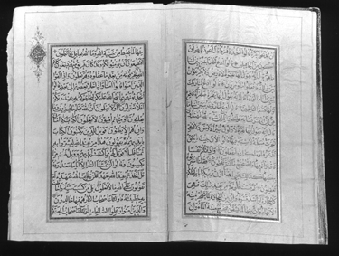
Muhammad/Mohammed (c. 570-632)
Born in 570 in Mecca, a thriving trading society, Mohammed began to receive revelations around the age of 30. He transmitted these to his followers, who wrote them down into what became the Koran after his death. He became not only a spiritual leader, but a political one. The faith he proclaimed united all of the Arabian tribes.

Rise of Islam
After Mohammed’s death, the now-united tribes began conquering neighboring nations and created an Empire that defeated both the Persian and Byzantine Empires. They attempted to take Europe, but were defeated in 732 by Charles Martel. Islam continued to rise until Moguls arrived in the thirteenth century.

Islam and Muslim Beliefs
Muslims believe there is one God (Allah) and that he revealed his teachings to the Prophet Mohammed, which were written down in the Quran (Koran). The Koran is made up of verses categorized into longer Suras, similar to chapters, and is designed as a dialogue between Mohammed and God as well as between Mohammed and the people (who were often hostile). The Koran incorporates many people and situations from the Bible, altering them to make them fit Islamic beliefs. Adam, Noah, Abraham, Moses, Jonah, Joseph, and Jesus are among those who appear in the Koran as well as the Bible. Their roles are separated from Jews and Christians entirely; they were Muslim prophets whose teachings were wasted on Jews and Christians. The Koran corrects the misconceptions and twisting of the teachings of these prophets as misrepresented in the Torah and the Bible.

The Five Pillars of Islam:
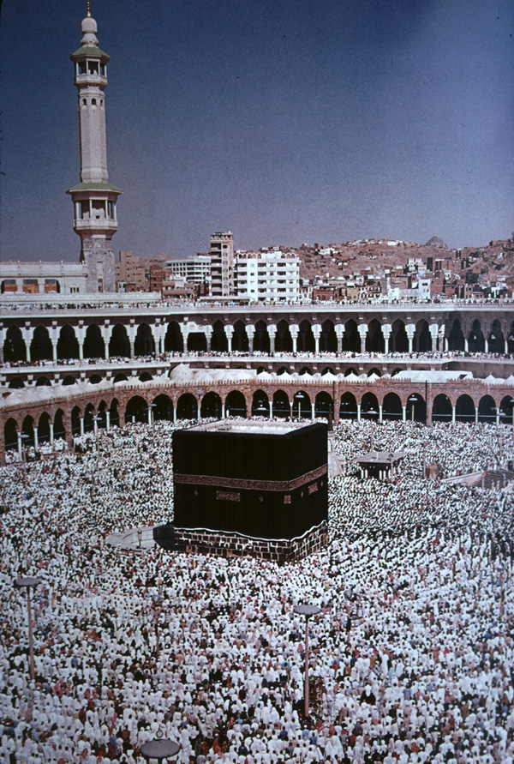
- Pray five times a day
- Fast during Ramadan
- Make pilgrimages to Mecca
- Believe “There is no god but God, and Mohammed is his prophet”
- Give to the poor

Fundamental beliefs:
1) There is only one God, and he
rewards those who believe and
punishes those who do not
- Angels exist as divine beings
- The Koran is the word of God
- All of God’s messengers and prophets speak the truth and must be believed fully
- All men will face a day of judgment; resurrection rewards the righteous, but the unbelievers will be eternally damned
- Fate (Qadar) is set out by God and drives one’s life
- Life is just a test

