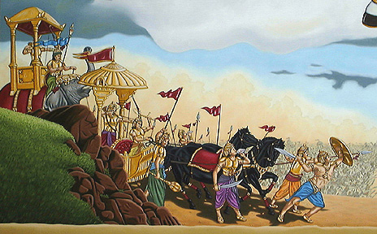

Mahābhārata
(c. 400 BC – 400 AD)

This work is an epic about the battles between the Kauravas and Pāndavas tribes in the Bhārata War. They were fighting for the right to rule Kuruksetra, but the scope is beyond a section of territory. As part of Hindu scripture, the Mahābhārata serves as a narrative of ancesty of the Indian people, a source of common cultural mythology, and an illuminator of philosophy through its parables. It also speaks of the four goals of life: “kama” or pleasure, “artha” or riches, “dharma” or duty, and “moksha” or freedom (the ultimate goal of life). It grew and expanded over time – hence the 800 year authorial date above. Due to the length of time, specific context is not easy to pin down. However, the culture of ancient or “heroic age” India was stable enough to get an idea of the culture that informed the work, and the Hindu culture that grew from it.

Context
From 1500-200 BC, the main scripture was the Vedas, derived from hymns. These were not written down until much later. The society valued the discovery of divine knowledge in man and cultivating it. From this originated dharma (see above) and “karma”, which was the principle that every action, good or bad, is paid for eventually – whether in this life or the next. During this period, the “caste” or class system was very rigid (after all, if you were poor, you must have something to deserve it in a former life). Gender roles were also very traditionally defined: a woman’s ultimate goal was to serve her husband well. The values of a warrior society were held high: great import was placed on ritual, strength, honor, and pride.
Author
Its “author” is traditionally Krsna Dvaipāyana Vyāsa. He is said to have dictated the tale to another – the elephant god Ganesha. He is not just the author, though; he is an important character as well. Like Gilgamesh and Homer’s epics, the poem derives from an oral tradition – tales recited by “sūtas” (bards) or priests.

Structure
The poetic meter of the majority of the work is in ślokza couplets (see pgs. 893-894) but there are passages in tristubh (see pgs. 957-958).

The story is divided into 18 books:
Books 1-5: Prelude to the Bhārata War (parva)
Books 6-10: Fighting the Bhārata War
Books 11-18: Aftermath of the Bhārata War
For plot summary, see pgs. 854-956 of your book

Major Characters
Protagonists: the five Pandavas. Sons of Pāndu, but technically fathered by gods, since Pāndu lived under a curse which stated he would die the moment he acted on sexual desire.
Sons of wife Kuntī:
- Yudhisthira: Fathered by Dharma. Good at sacred law, but not fighting.
- Bhīma: Fathered by Vāyu. Large appetites, great strength and spontaneity.
- Arjuna: Fathered by Indu. Good both on the battlefield and in the bedroom.

Sons of wife Mādrī
4) Nakula and 5) Sahadeva: Fathered by twin gods Aśvins. Also twins who both excel in beauty and healing.

Antagonists: Duryodhana and his 99 brothers, the Kauravas: Sons of Dhrtarāstra and Gāndhārī.

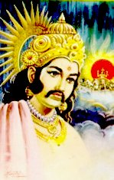
Ambivalent: Karna: Son of Kuntī and the sun God. Thrown into a river. Raised by charioteer and wife; grew up strong. Born with armor and earrings fused to his body, but cut them off at the request of the King of the Gods Indra (disguised as a Brāhmana). As a reward, he received the Śakti weapon, which killed anyone at whom it was aimed. The Kauravas get behind Karna because he is a match for Arjuna. Duryodhana even gives him his kingship so that Karna can show up Arjuna (only a king could battle Arjuna one-on-one).

