The Roman Empire in the Age of Augustus and Virgil

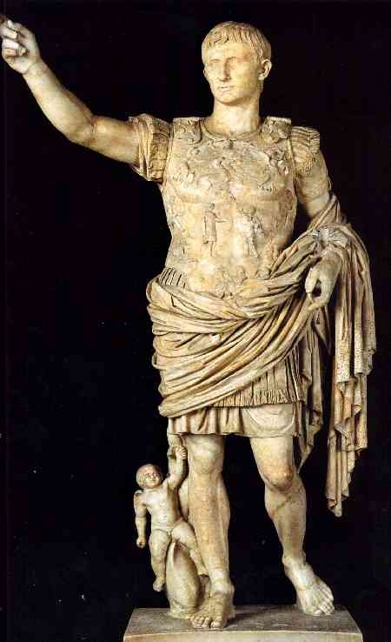
Virgil (70-19 BC) lived under the rule of Augustus Caesar, the first emperor of Rome. It was a time of changes as Rome emerged as a “world-state.” Augustus started elections, but rigged them so the “best man won” – even if the best man was lower-class. He gave Roman citizenship to all Italians. He resettled soldiers on farmland, reinforcing agrarian culture. Most importantly, he turned the army from a volunteer force to a standing, professional army. Their presence was constant and the empire became almost a “police state.” Through this strict authoritative presence, the Romans were able to keep the provinces in line and also spread their language (Latin) and culture. Due to good leadership, his era was one of peace. Literature also flourished; poets were government-sponsored. Besides Virgil, Ovid and Horace wrote at this time.

To reflect his role, Virgil put in the Aeneid patriotic themes extolling Rome and its values, the main three of which were manliness, industry, and discipline. Aeneas is willing to sacrifice his life and happiness for his future and his country. This is part of the “Stoic” philosophy, which held that the purpose of the universe was divinely formed and called logos. Even though humans could never understand logos, they must follow its dictates – fulfill their destiny, so to speak.

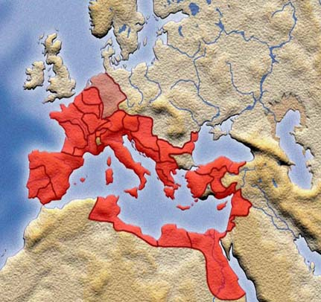
Scope of the Roman Empire at the Death of Augustus

Under Augustus, the Roman empire was able to cement a centralized control that stretched across Europe and as far as Africa. For two hundred years, Rome was able to keep a degree of peace and expand further before civil wars tore it apart.

