Son-Jara (Late 13th – Early 14th Centuries)

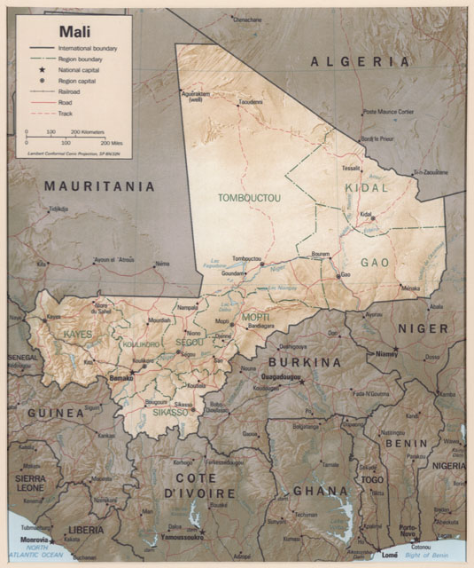
This work recounts the founding of the Mali empire in Africa by Son-Jara Keita, who came into power in 1235. It is the national epic of the Manding people. Like many works we have studied, Son-Jara was created from an oral tradition. Also, like many national epics, Son-Jara helps establish a shared values and cultural history for an entire society. Because of its political nature where a national hero is presented as a “good” force which overcomes the “evil” rival (Sumamuru), the epic gives the Manding people a sense of common pride of ancestry, culture, and national legitimacy which could unite them as a people and military force.

The History of the Mali Empire
The Mali empire began its rise in the thirteenth century, largely due to the increased spread of Islam in the region which had begun in the seventh century. The emphasis placed on the Muslim text of the Koran, which is only considered legitimate if read in Arabic, encouraged literacy. The required learning of Arabic also gave the elite of the tribes a shared language. This helped the Manding people to unify and form one of the three major empires of Africa in medieval times (along with the Songhay and Ghana empires).

The Character of Son-Jara
Little is known about Son-Jara Keita historically, although he did exist. In the work, his father (Fata Magan the Handsome) descends from Bilal, a follower of Mohammed, thus giving him Islamic currency. His mother (Sugulun Konde the Ugly) is a native African whose family is involved in magic, thus giving him a sorcerer’s abilities and a native’s right to rule. He is presented as a powerful founder like Adam, and he is also called Sundiata and Mari Jata. The epic spends a lot of time establishing his heritage and legitimacy. However, in the latter half of the epic, his own story and ascendancy comes into play. In many ways, his exile and path to rule reflect Mohammed’s. It is only in the seventh and final episode that Son-Jara comes into power and begins to build and expand the Mali empire.

The Oral Tradition
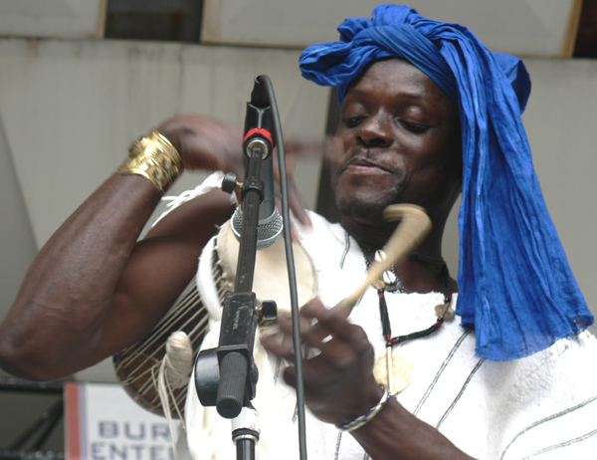
To this day, there is a rich oral tradition in Africa. It merges folklore, legend, myth, and poetry. The tales are transmitted by bards, called dyeli or belein-tigui in Mandin and griot in French (see photo for a modern-day African griot). These bards held a place of honor and traveled with the elite and royalty. Not only is a bard telling this tale, bards are characters in it. As time passed, more tales were added to Son-Jara, taking it from a series of praise poems to an epic of a national hero founding an empire. As a result, it contains three distinct genres: a narrative framework of structural episodes and genealogies, praise poems, and songs. Even the oral recitation in the original Mande language is very rhythmic and song-like. You will see in the text, in parenthesis, representations of answering chants/interjections that audience members are expected to provide (call/answer form); the bard’s apprentice is the lead answerer, here referred to as Bemba.

