The Trojan War – 1200 BC
It all started with a wedding party gone bad. Peleus, the King of Aegina and the father of Achilles, was getting married to a minor sea goddess, Thetis. They decided not to invite Eris, the goddess of discord, for obvious reasons. She showed up anyway at the wedding banquet, enraged, with a golden apple. She threw the apple onto the table and said it belonged to the fairest woman there.

Hera, Athena, and Aphrodite each wanted the apple. Zeus decided that Paris, Prince of Troy, would decide between them because he was the most gorgeous man alive. Once Paris had been fetched by Hermes, each goddess tried to persuade him to pick her. Hera offered him power; Athena, wealth; and Aphrodite, the most beautiful woman alive. Driven by hormones instead of good sense, Paris chose Aphrodite in order to get the beautiful Helen for himself. The only problem: Helen was already married to King Menelaus of Sparta. Promised possession of Helen anyway, Paris sailed for Sparta.

When Paris showed up, the unsuspecting Menelaus treated him with honor and respect. That did not stop Paris from kidnapping Helen when Menelaus was off at a funeral and bringing her back to Troy – along with a good-sized stash of Menelaus’ treasures that he grabbed on the way out. Of course, Menelaus was not about to just shrug off the insult and pretend it never happened. He gathered an army and headed for Troy, where the ten-year Trojan war began. Members of the Greek army included Odysseus, Achilles, and Agamemnon. On the Trojan side, the hero of Troy was not the handsome Paris, but the honorable and noble Hector.

After figuring out where Troy was, the Greeks arrived and began attacking both Troy and its neighboring allies. Their strategy combined an intensive siege with traditional battles. Despite nine years of fighting, they simply could not get past the Trojan walls.

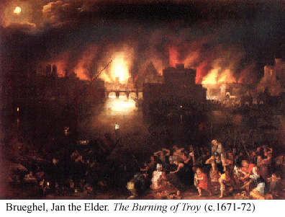
Odysseus, known for his intelligence, suggested they try a trick – the famous Trojan horse. It was a large, hollow wooden horse designed to be able to hide soldiers within it. A contingent of Greek warriors got inside the horse as the rest of the Greek fleet sailed out of sight. They then sent a man to claim that the Greeks had fled and left only the horse, which was a good-luck piece for them. The ecstatic Trojans took the horse as a trophy of war. They brought it inside of their walls and held a huge party.

That night, the Greek soldiers snuck out of the horse and laid waste to the city, killing King Priam and raping his daughter Cassandra. Troy finally fell and the Greeks went home triumphant.

