Marguerite de Navarre and the Heptameron
The life of de Navarre (1492-1549)
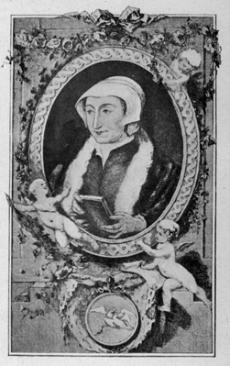
She was a queen of a small region in France called Navarre, and the sister of Francis I, the king of France. Due to the fact that her father died not long after she was born, de Navarre was used to strong female figures. Her mother ensured she was educated, but at 16, she was married off to Charles, duke of Alençon. After her brother rose to the throne of France, she participated in his court and lived away from her husband. When her brother was captured in 1525 by the Holy Roman Emperor, Charles V, as he was out on a military campaign, she became instrumental in obtaining his release. By the time Francis I returned to reign, de Navarre’s first husband had died. Not single for long, married Henri d'Albret, king of Navarre, in 1537.
As an influential member of her brother’s court, she was a patron of poets and artists. She also began to concern herself with matters of the Catholic church, advocating reform and the publication of Scriptures in French. After her brother’s death, she went into self-imposed exile and concentrated on her writing.
The Heptameron (1599)
De Navarre’s most famous work is the Heptameron. It was published in 1599, after her death, and inspired by Bocaccio’s Decameron. It is a collection of stories; according to the premise of the work, the stories are told over seven days (ten stories a day) and, on the eighth day, two more stories are added. The stories do not communicate a consistent theme, which causes some to criticize it and argue she did not write it all herself. Some of the stories are moralistic, some are scandalous; some support the status quo; some argue against it. Whether she wrote all of the stories herself or compiled/modified stories from some of the several authors who visited court, she was the guiding hand behind it. The work still stands as a hallmark not only for women writers, but for French works of the Renaissance.

