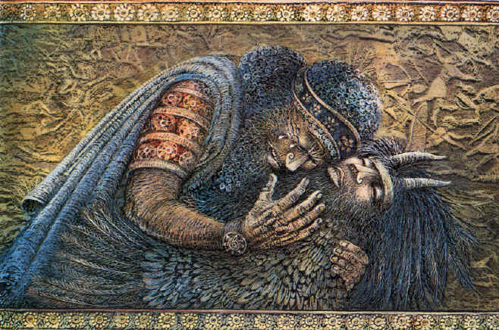
Enkidu dies in Gilgamesh’s arms

Discussion Questions

What are Gilgamesh’s character traits, strengths and weaknesses? What are Enkidu’s?

What is the relationship between the wild and the civilized?

Why is sex considered a civilizing force?

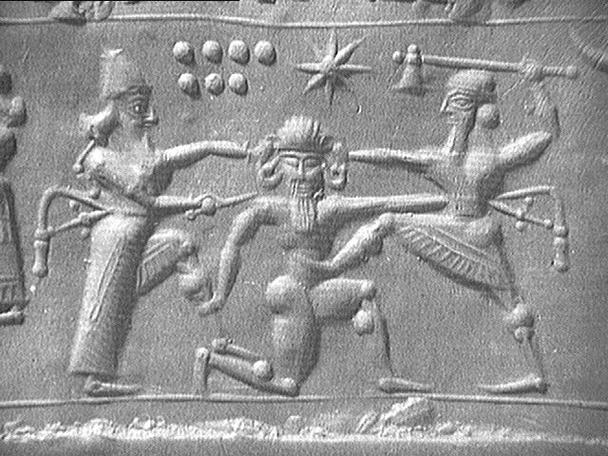
What is the relationship between mankind and nature? How does the killing of Humbaba play into this?

What are the female characters like? How much power do they have?

What elements inspire the tight male bonding?

What kind of messages do we get from the tale about death, man’s mortality, and harsh reality? How does Gilgamesh’s reaction to the death of Enkidu inform this? How do Utnapishtim and the flood play into this?

How does the story of Utnapishtim compare with the story of Noah’s Ark?

What is the significance of the sleep test Utnapishtim asks Gilgamesh to do? What about the plant that promises youth and is captured by the snake?

Why so many dreams? What are they about? What do they mean?

How does one attain wisdom and maturity? What should one do to be happy?

