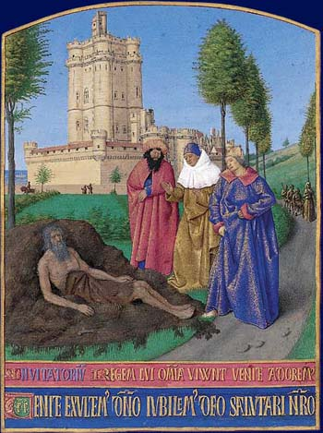
Book of Job: Background

The author
We do not know who authored the book of Job, but before it was written down for future generations, it was passed along orally. Some credit the book to Moses, but he is never named as author and that is just speculation.

When the book was written
There is more than one theory about when the book was written. Some say it is the oldest book in the Bible, written around 1600 BC (the time of Abraham) or 1500 BC (the time of Moses – see above). Others believe it was later; theories include 900 BC (the time of Solomon), 700 BC (the time of Isaiah) 550 BC (the time of the fall of Jerusalem to Babylon) or 400-300 BC (during the Babylonian exile).

The setting
The time period cannot be determined precisely; most scholars speculate that the setting puts Job in the time of Abraham. The book says that Job is from Uz, but no one knows where exactly that was located. Scholars have speculated it might have been south of the Dead Sea in Edom. We do know that Eliphaz the Temanite, one of Job’s friends, was from the capital of Edom. If the book was written by Abraham, it could have been set in his stomping grounds of Haraz.

Authenticity
Theories of whether or not Job was a real person fall into three camps: yes, he was real and the story is literal; yes, he was real and the story is based on true events, but is embellished; no, he is a literary construct for the purposes of parable.

Cultural background
Job lived in a patriarchal society. Great importance was placed on leaving a legacy through a son. Land ownership was also a sign of status. The most common professions were those of farmer or shepherd, but in large cities merchants of all sorts thrived. One’s family played a large part in what one’s profession would be. If a man was a Levite, for instance, he was expected to work in the temple. The eldest son was expected to carry on the “family business.” Respectable women were expected to play domestic roles. There was not a lot of upward mobility.

Religious background
Job was a Hebrew, and practiced Judaism. Judaism is a faith with one God. Traditionally, Israelites believe they are God’s chosen people and will enjoy his favor as long as they follow his commandments. If they disobey him, they must sacrifice in order to show their repentance. God will forgive the sins of those Hebrews who are sincerely repentant and conduct the proper sacrifices. The high level of specificity and detail of the rules places a great deal of importance on the letter of the law.

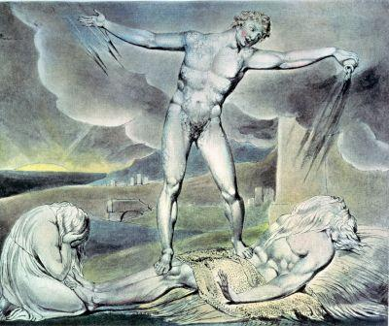
Literary categorization
Job is known as part of the “wisdom literature” of the Bible, like Proverbs, because of its intensely focused lesson. It is also categorized as one of the “poetry books,” like the Song of Solomon, due to its poetic structure and metaphorical language.

Literary structure
Job has a narrative framework that is divided into three main parts: Prologue, Dialogue, and Epilogue. Each plays a different role in the progression of the work. The Dialogue can be split into the following parts: 1) Job’s opening speech 2) Dialogues with friends – Job’s friends speak in sets, first Eliphaz, then Bildad, then Zophor. However, in the third set, Zophor does not get a turn. 3) Elihu’s speech 4) Dialogue with God.

