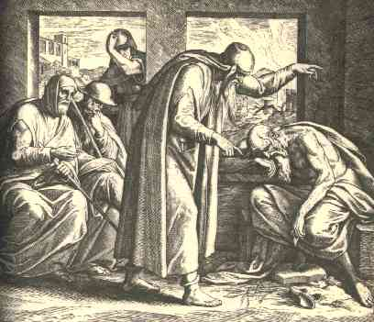
Study Questions for The Book of Job

What is the purpose of the book of Job? What message are we as readers meant to learn?

What lesson does Job learn? He doesn’t know as much as the reader does about why this happened. How does that affect what he learns as opposed to what we learn?

How does the tone of the friends’ speeches change? Are there differences in their approaches? What is their fundamental mistake when counseling Job? What do they learn?

God is trying to teach Satan a lesson, too. How does his lesson inform ours? Is it different?

Job’s wife is the only woman in the story. She tells Job to curse God and die – basically, telling him to commit suicide in the worst way (one with eternal implications). Obviously, this is a different approach than Job’s friends. Why do you think she told Job to do this?

What is the role of Elihu?

What do you think of the way God reveals himself to Job? Why do you think he chose it?

Analyze the conflict of faith as opposed to reason in the book of Job. What wins?

In the end, Job’s wealth is restored, and more. This seems like a reward for his virtue – but is it? How does the answer to that question affect the message, if at all?

If worshipping God and following the rules isn’t rewarded by success in this world, why should one do so, according to the book of Job? Why doesn’t Job fault God in the end?

